**SUPERSET ID: 6065629 NAME : SHREYAS P P**

**Exercise 1: Control Structures**

**Scenario 1:** The bank wants to apply a discount to loan interest rates for customers above 60 years old.

* + **Question:** Write a PL/SQL block that loops through all customers, checks their age, and if they are above 60, apply a 1% discount to their current loan interest rates.

**ANSWER:-**

**Create the customers and loans Tables**

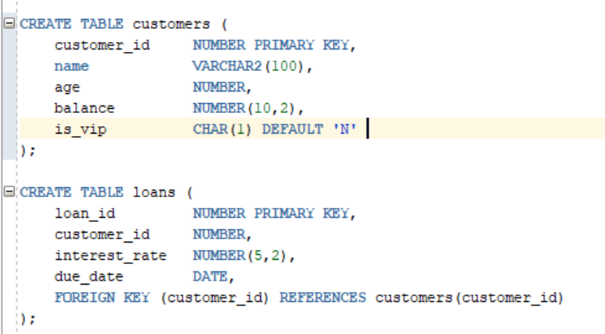

**Insert Sample Data**

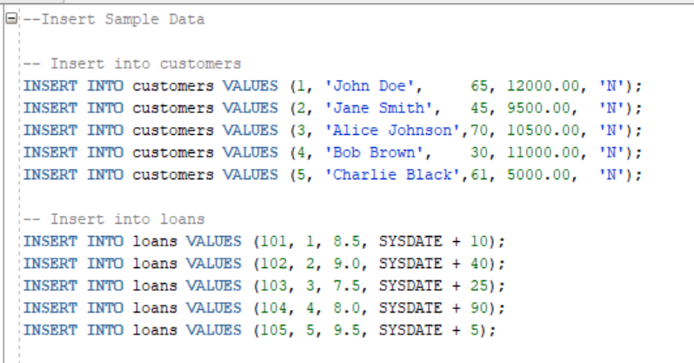

**Apply 1% Discount for Age > 60**

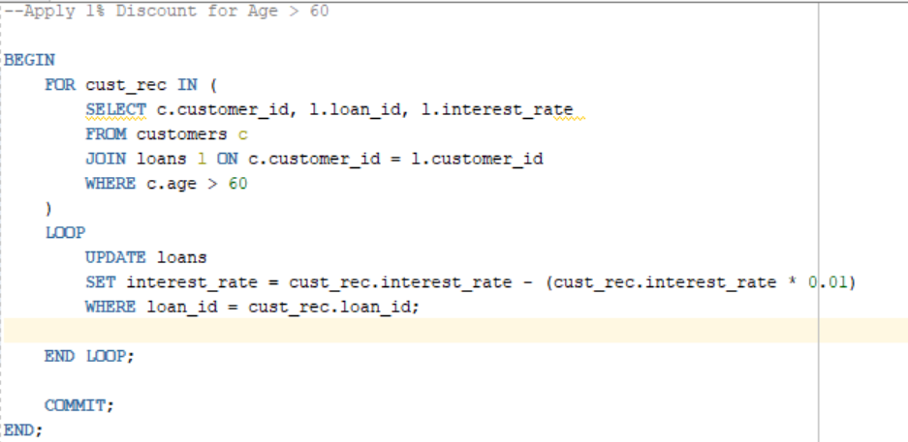

**Output**

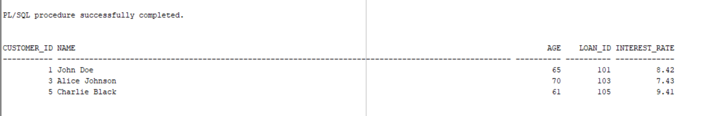

**Folder Structure**

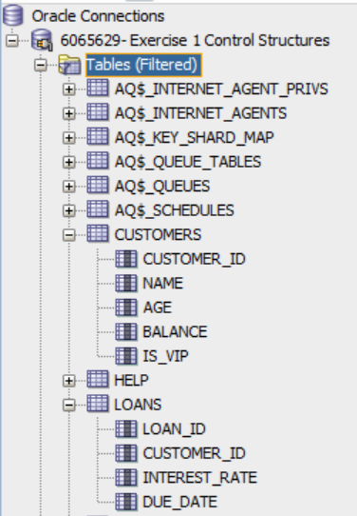

**Scenario 2: A customer can be promoted to VIP status based on their balance.**

* + Question: Write a PL/SQL block that iterates through all customers and sets a flag IsVIP to TRUE for those with a balance over $10,000.

**ANSWER:-**

**Create the customers and loans Tables**



**Insert Sample Data**



**Promote customers to VIP status if their balance is over $10,000.**

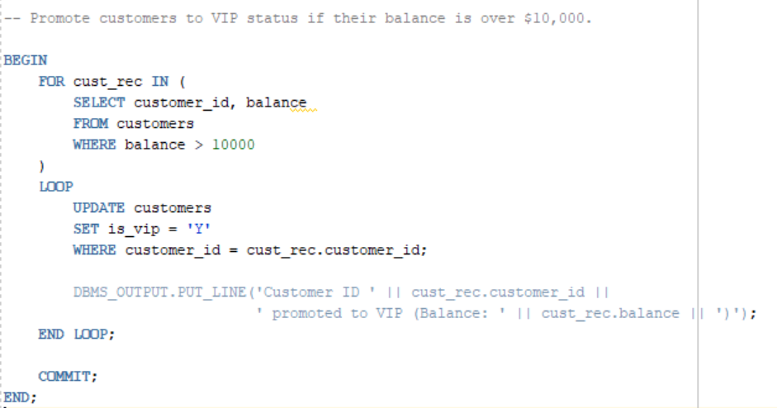

**Output**

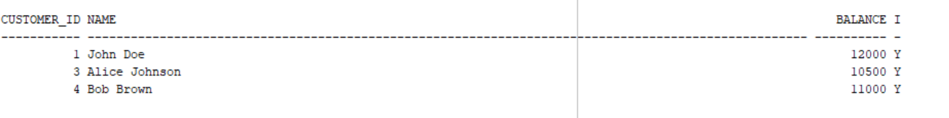

**Folder Structure**



**Scenario 3: Ensure data integrity when adding a new customer.**

* + Question: Write a stored procedure AddNewCustomer that inserts a new customer into the Customers table. If a customer with the same ID already exists, handle the exception by logging an error and preventing the insertion.

**ANSWER:**

**Write a stored procedure AddNewCustomer that inserts a new customer into the Customers table**

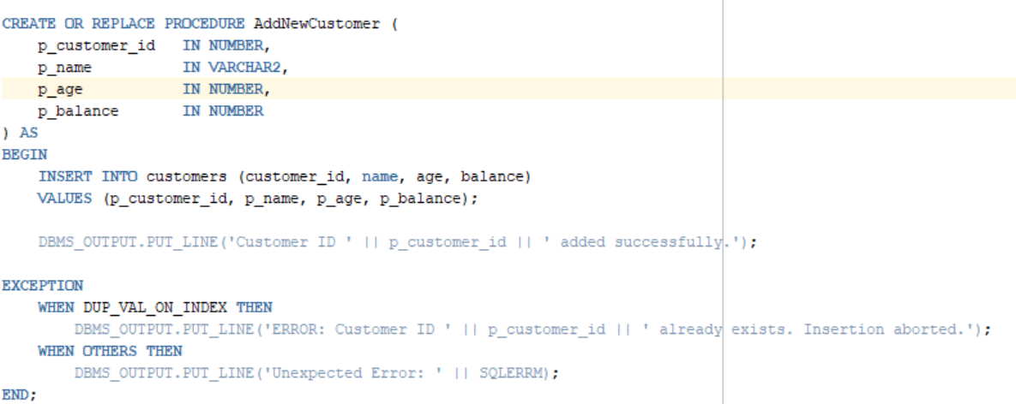

**Output**

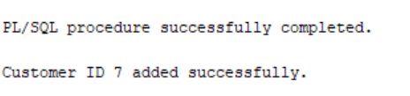

**When same ID is repeated**

